Thai Bao Nguyen (ID: 105531767)
Unit code & Title: SWE40006 Software Deployment and Evolution
Assignment: Deployment Portfolio Task 3
Semester 2 – Submission date: 10/9/2026
Declared Target Level: Task 3.4 – High Distinction Level
Application Load Balancer DNS Name: http://swe40006-wordpress-alb 1145210626.ap-southeast-2.elb.amazonaws.com
EC2 Public IP: http://3.26.181.106
Github: https://github.com/ThaiBaoNguyen06/SWE40006-AWS-Deployment-Portfolio Task3.git
Task 4.1: Pass Level
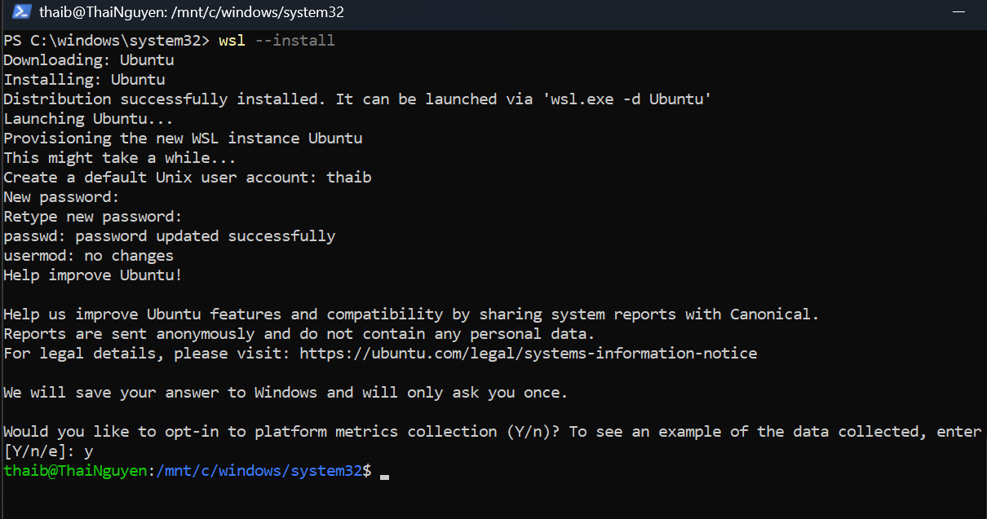
Figure 1: Windows Subsystem for Linux (WSL) and Ubuntu were successfully installed to support the Docker Desktop runtime environment.
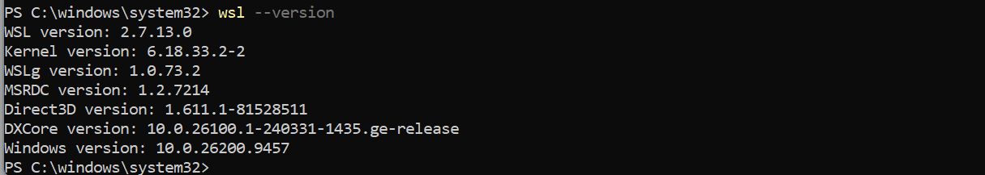
Figure 2: WSL was verified successfully with version 2 configured as the default environment for Docker Desktop
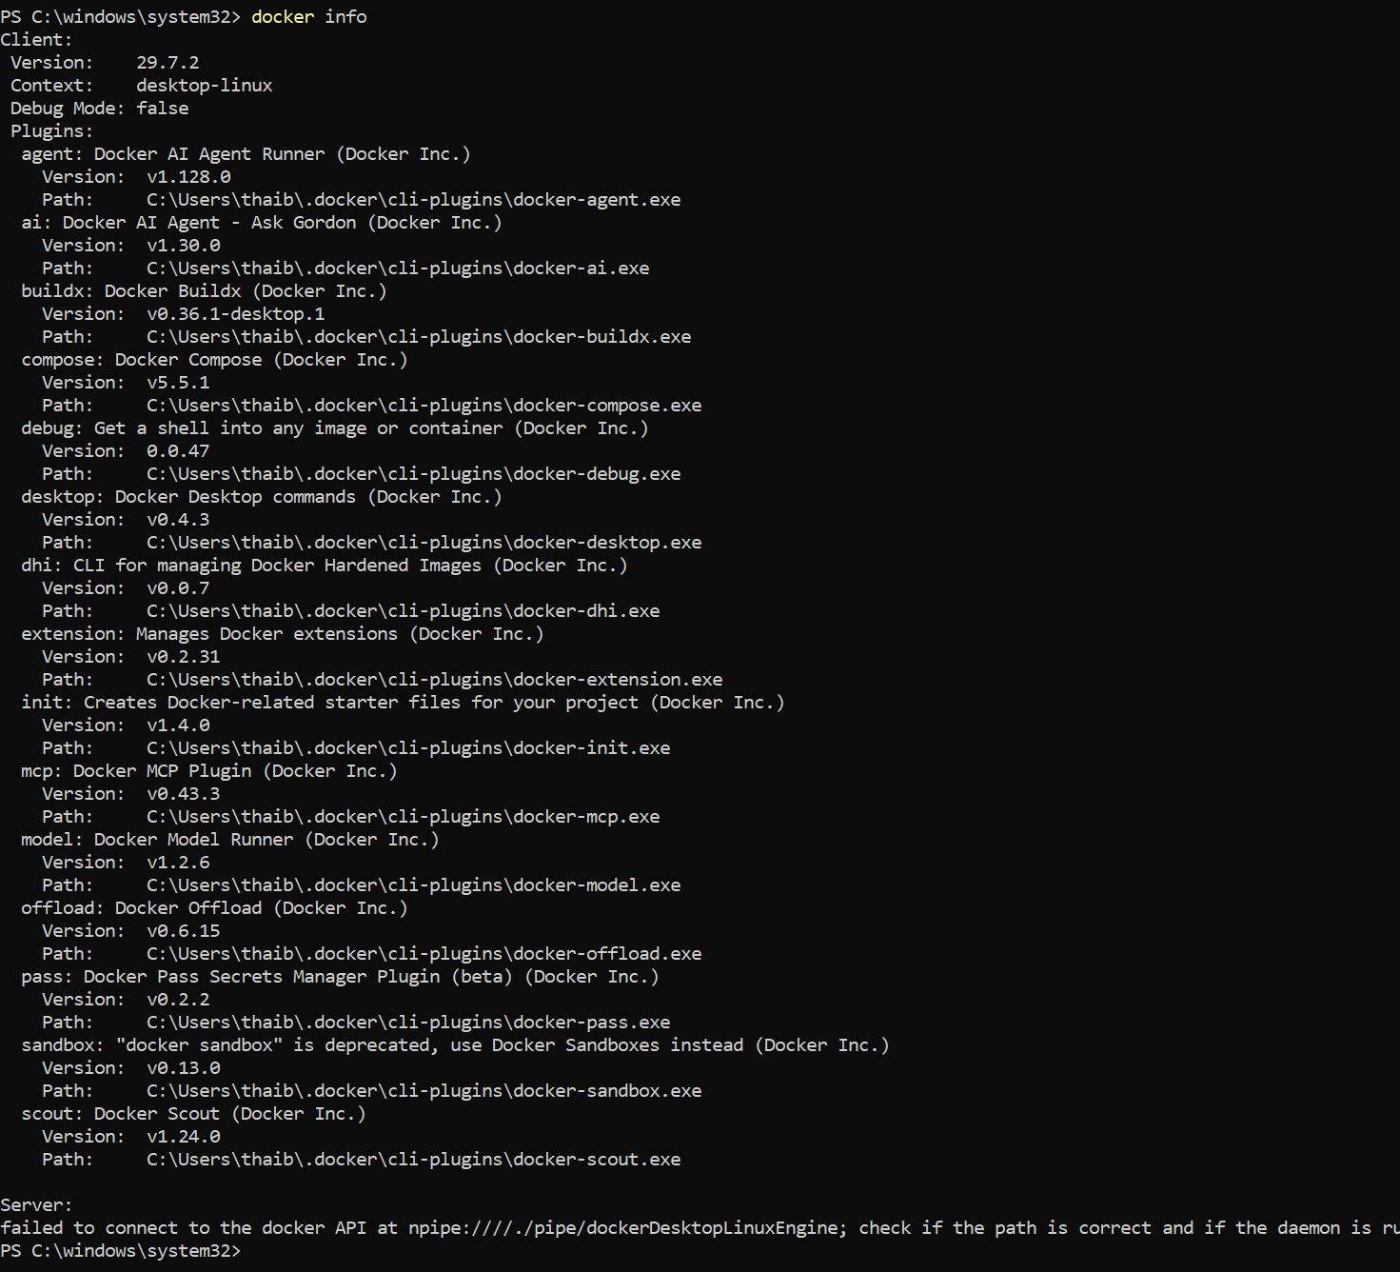
Figure 3: Docker Engine and Runtime Verification
The docker info command was used to verify that the Docker client and Docker Engine were running correctly and ready for container deployment.
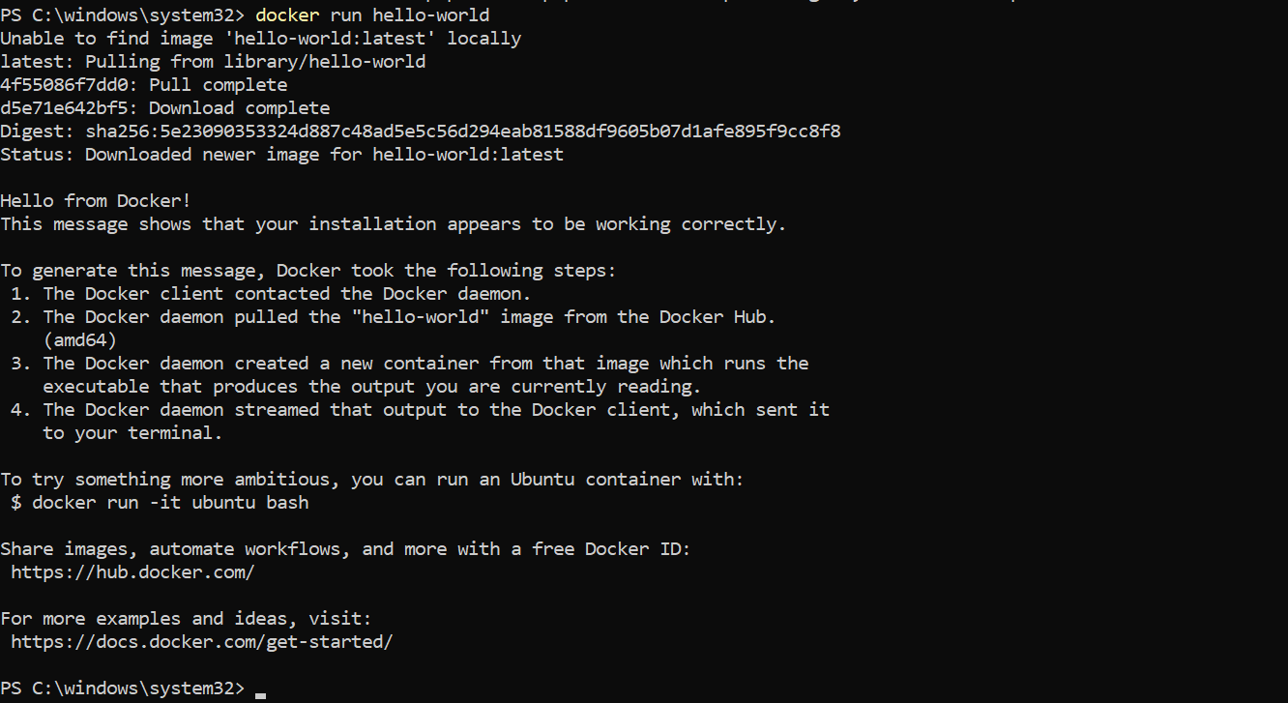
Figure 4: Running the Docker Hello-World Container
The official hello-world image was successfully pulled from Docker Hub and executed, confirming that the Docker runtime environment was working correctly.
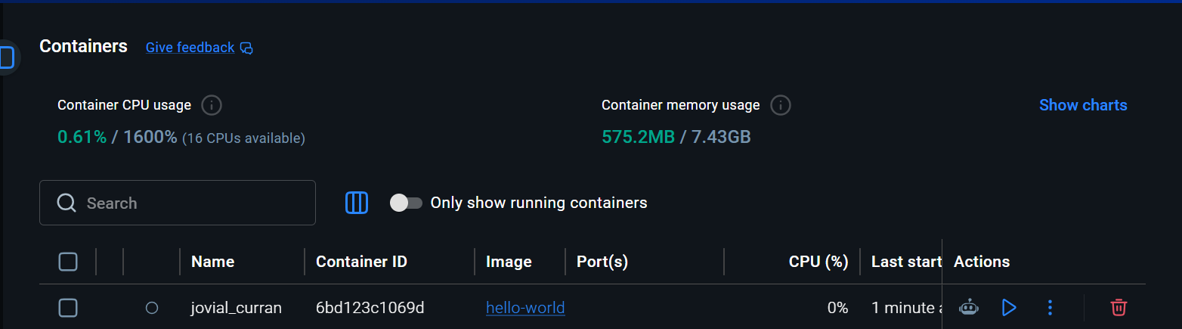
Figure 5:Hello-World Container in Docker Desktop
The successfully executed hello-world container is displayed in Docker Desktop, confirming that Docker can create and manage containers correctly.
Task 4.2: Credit Level
- Python Web Application Engineering
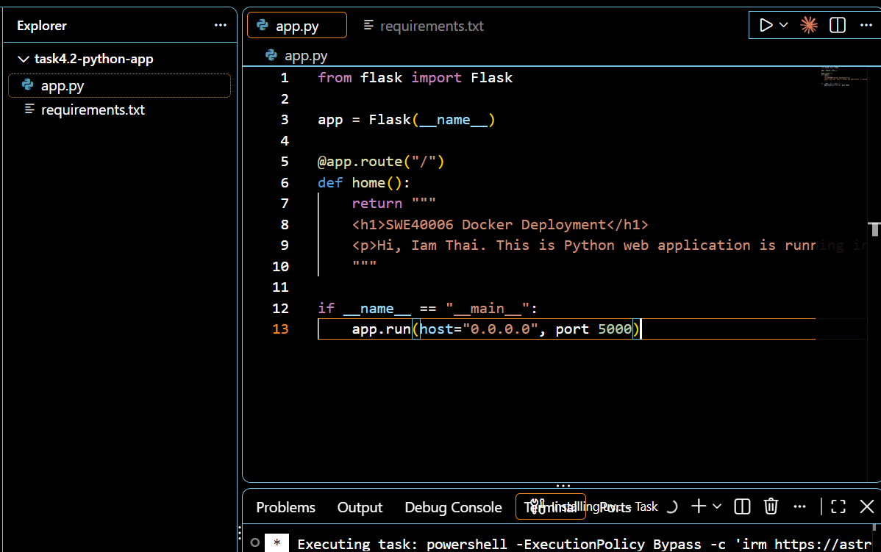
Figure 6: Python Flask Web Application Development
A basic Python Flask web application was developed to run on port 5000 and accept connections from the Docker container network.
- Containerization & Dependency Setup
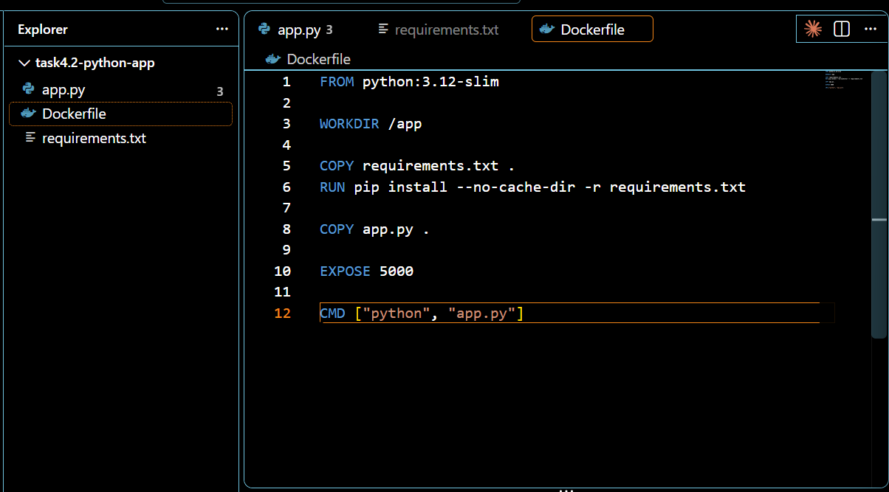
Figure 7: Dockerfile for the Python Flask Application
A custom Dockerfile was created to configure the Python runtime, install the Flask dependency, copy the application files, and expose port 5000 for the web application.
- Local Deployment
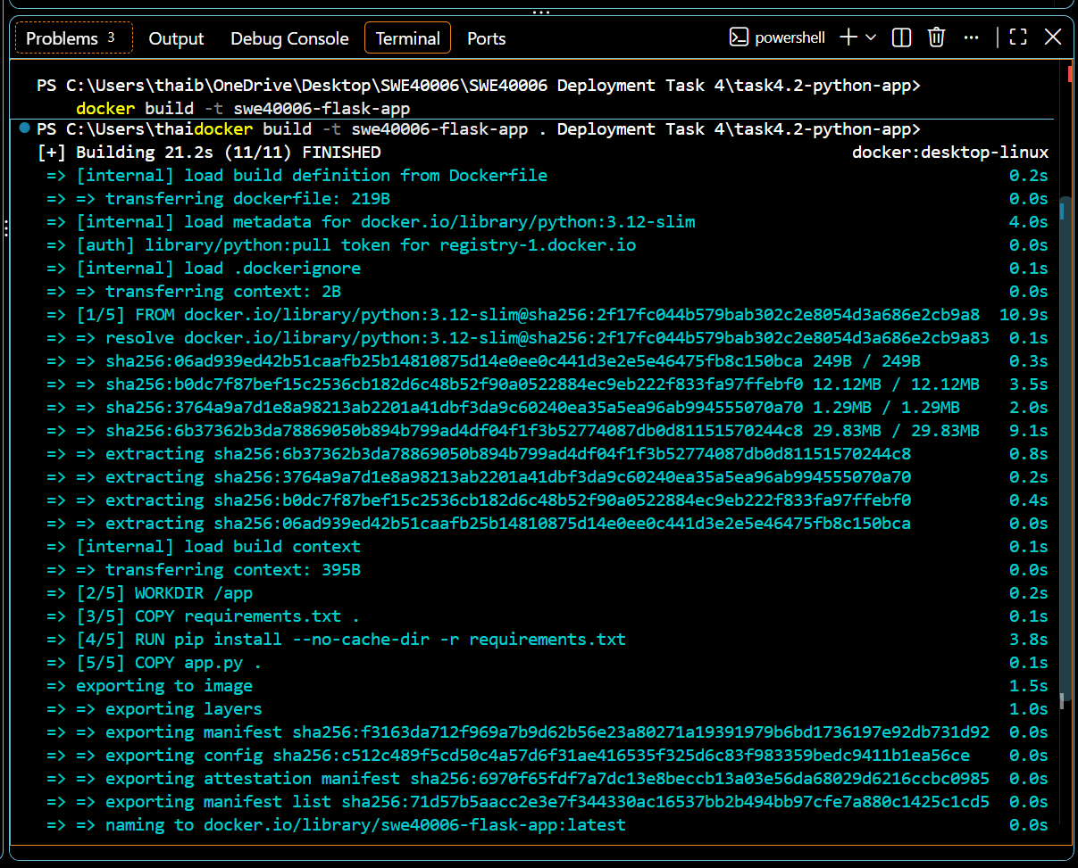
Figure 8: Building the Flask Application Docker Image
The Flask application was successfully built into a Docker image using the custom Dockerfile and required dependencies.
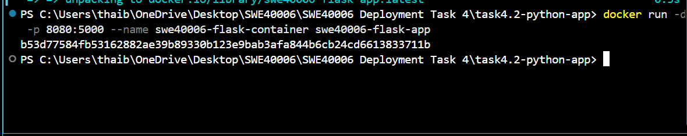
Figure 9: Starting the Flask Application Docker Container
The Flask application container was successfully created and started from the swe40006-flask-app image with port 8080 mapped to container port 5000.
Figure 10: Verifying the Running Flask Docker Container
The swe40006-flask-container was successfully running from the swe40006-flask-app image, with host port 8080 mapped to container port 5000.
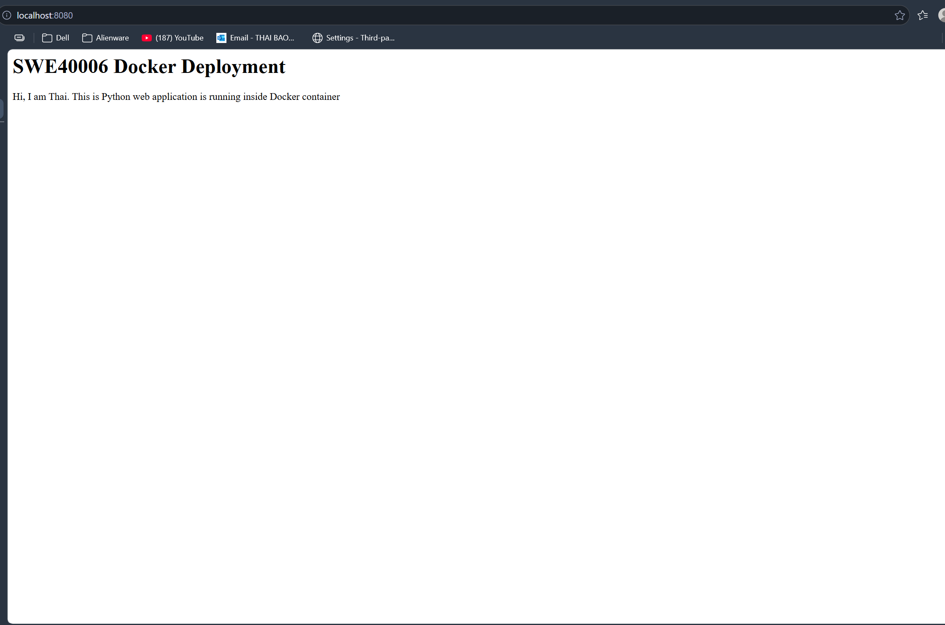
Figure 11: Accessing the Containerized Flask Application
The containerized Flask application was successfully accessed through localhost:8080, confirming that the application and Docker port mapping were working correctly.
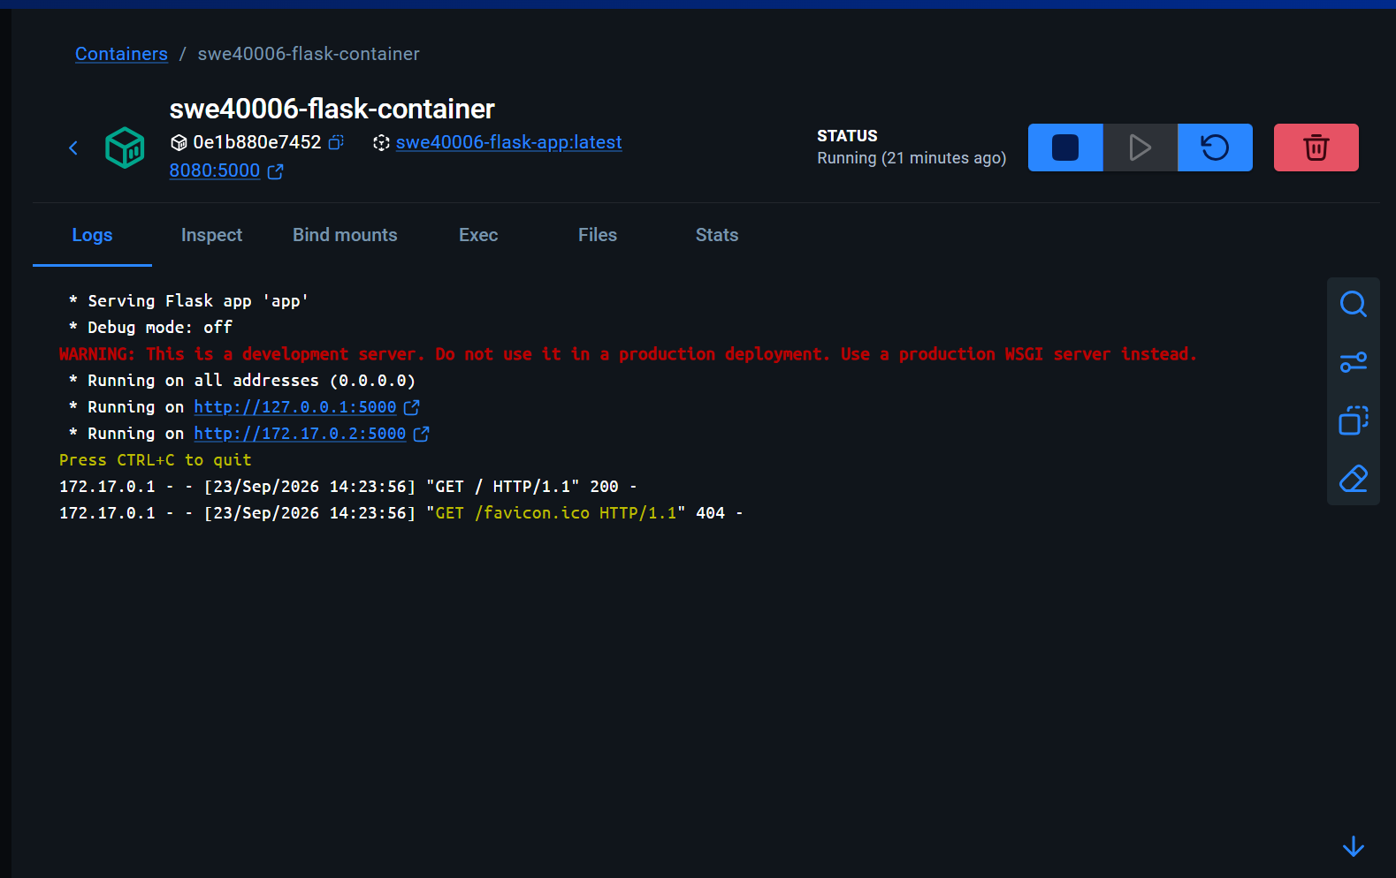
Figure 12: Running Flask Container in Docker Desktop
The Flask container was successfully running in Docker Desktop with port 8080 mapped to the application port 5000. The container logs confirm that the Flask application was accessible and successfully returned an HTTP 200 response.
- Multi-Host Verification
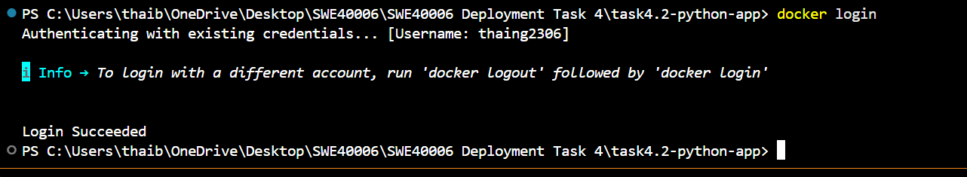
Figure 13: Docker Hub Authentication
Docker CLI authentication was successfully completed using the Docker Hub account
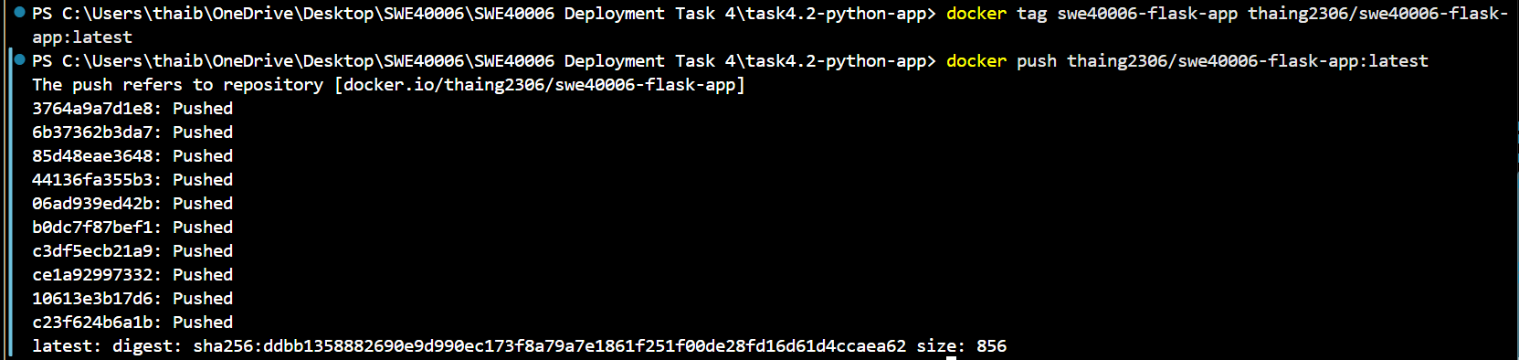
Figure 14: Pushing the Flask Application Image to Docker Hub
The swe40006-flask-app image was successfully tagged and pushed to the Docker Hub repository under the thaing2306 account.
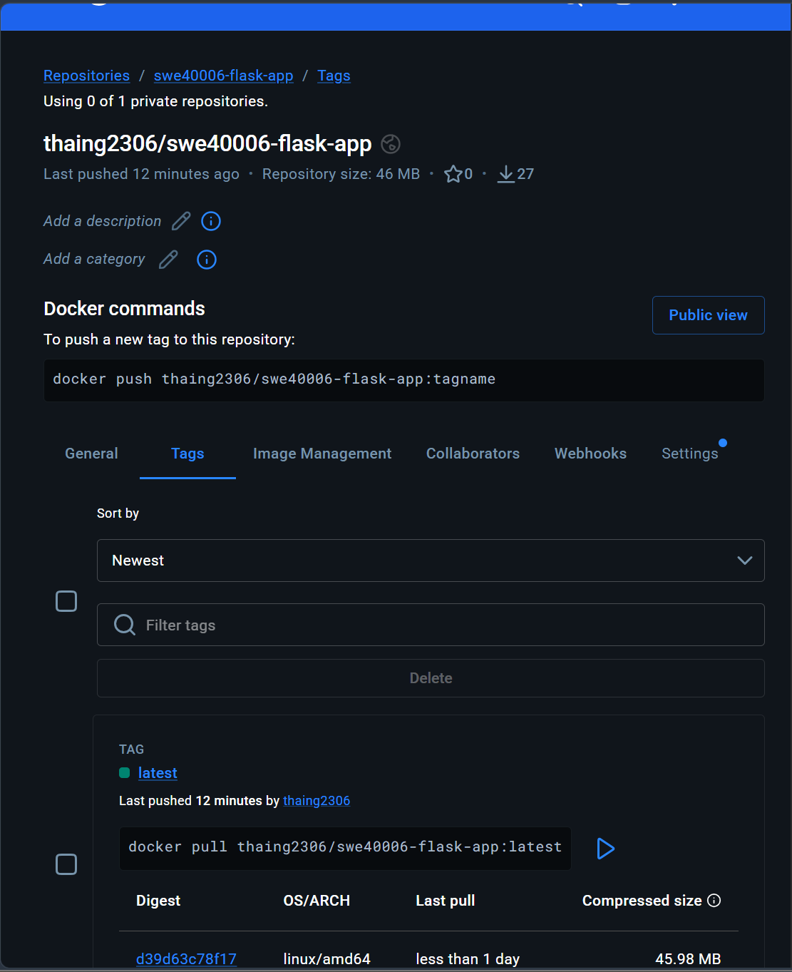
Figure 15: Flask Application Image Published to Docker Hub
The Flask application image was successfully pushed to the Docker Hub repository thaing2306/swe40006-flask-app with the latest tag, making the image available for deployment on another Docker host.
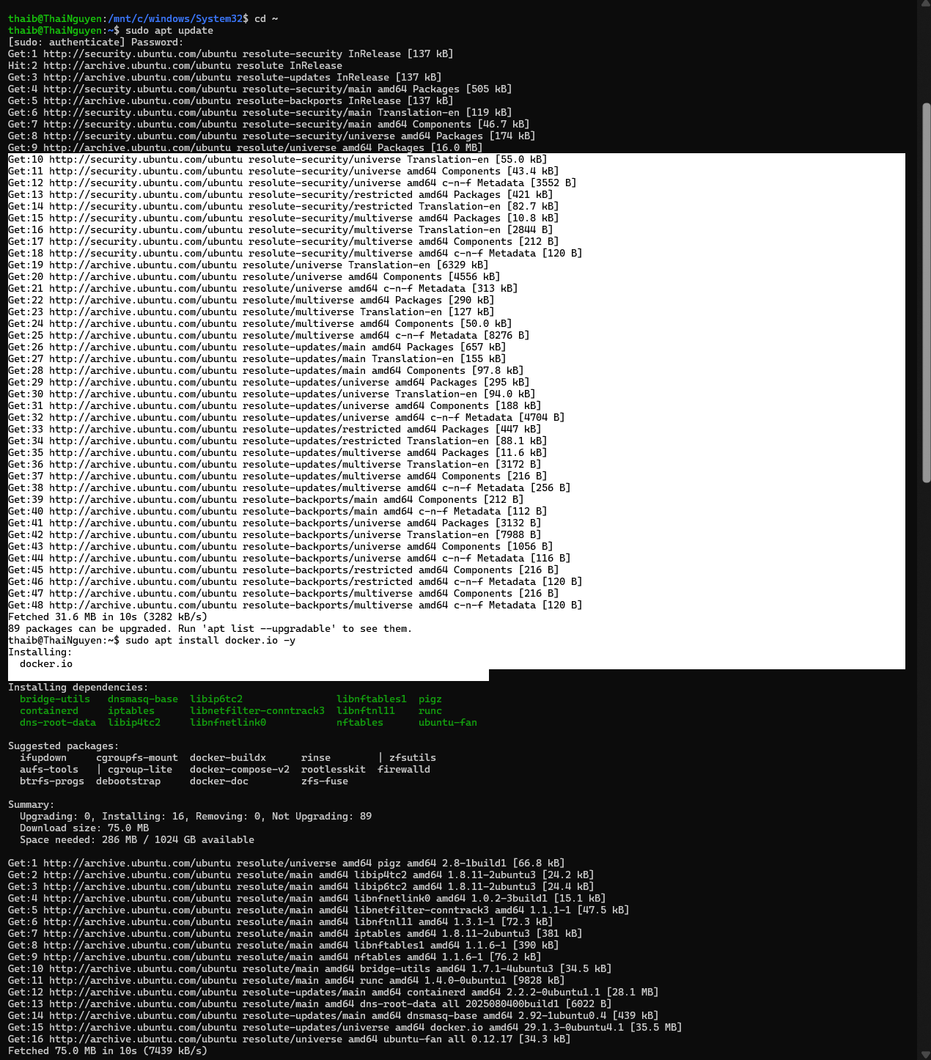
Figure 16: Updating Ubuntu Packages for the Secondary Docker Environment
The Ubuntu package repositories were successfully updated before installing Docker Engine in the secondary WSL environment.
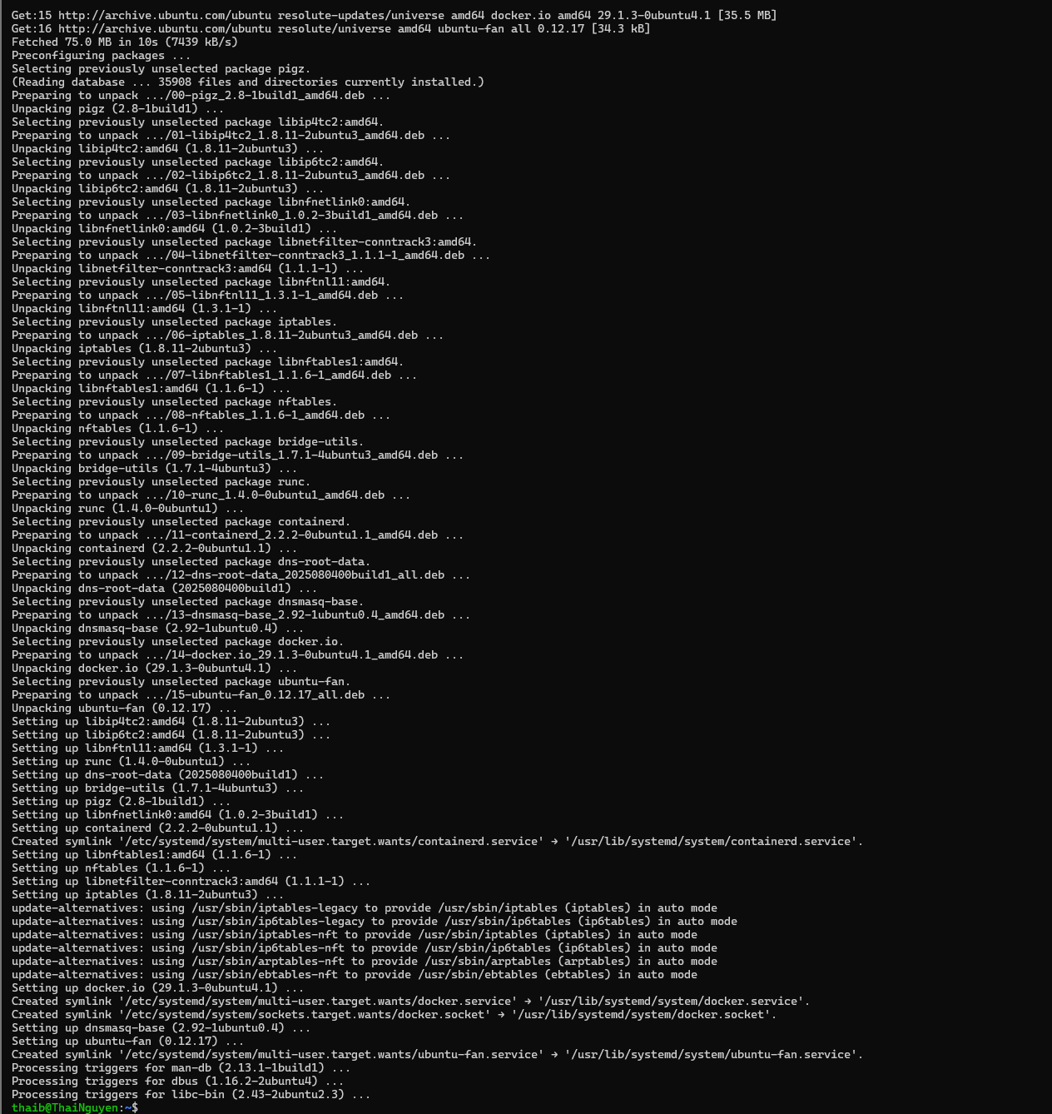
Figure 17: Installing Docker Engine on Ubuntu WSL
Docker Engine and its required dependencies were successfully installed on the Ubuntu WSL environment using the docker.io package.
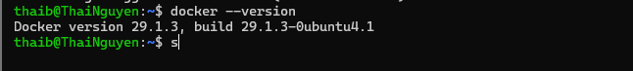
Figure 18: Verifying Docker Installation on Ubuntu WSL
The Docker installation was verified using docker --version, confirming that Docker version 29.1.3 was successfully installed.
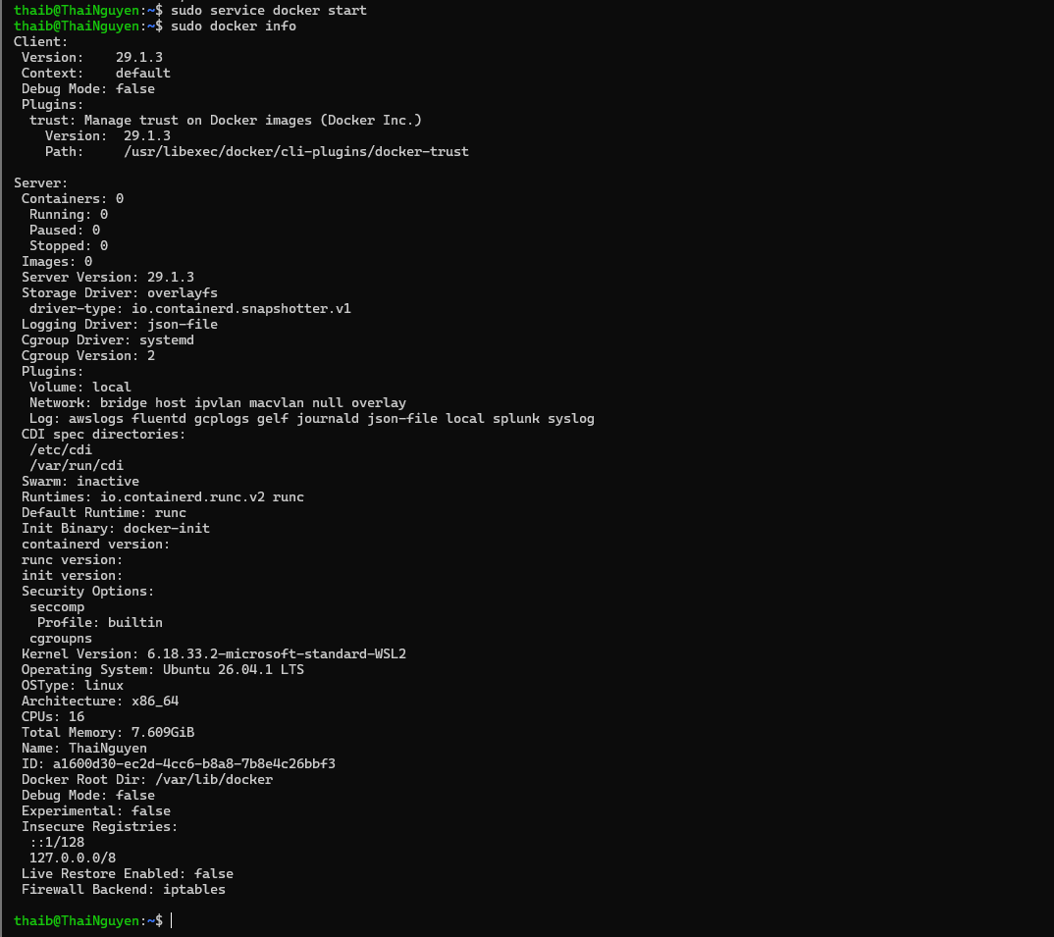
Figure 19: Verifying Docker Installation on Ubuntu WSL
The Docker installation was verified using docker --version, confirming that Docker version 29.1.3 was successfully installed.
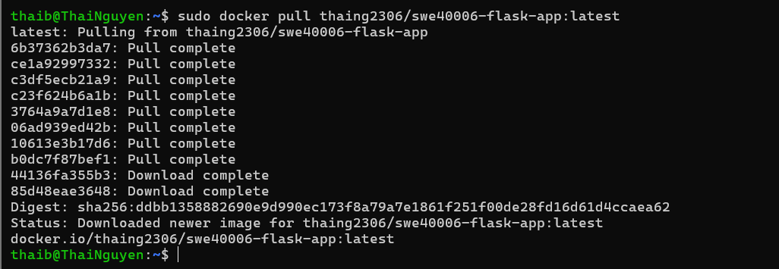
Figure 20: Pulling the Flask Image on the Secondary Docker Host
The Flask application image thaing2306/swe40006-flask-app:latest was successfully pulled from Docker Hub into the Ubuntu WSL Docker environment, confirming that the image can be retrieved on a secondary Docker host.
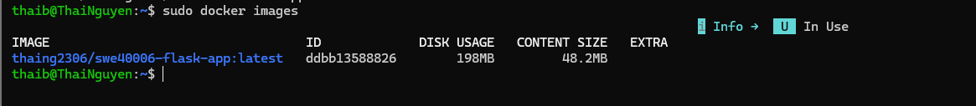
Figure 21: Docker Image Pulled to the Secondary Docker Environment
The Flask application image thaing2306/swe40006-flask-app:latest was successfully pulled from Docker Hub into the Ubuntu WSL Docker environment.
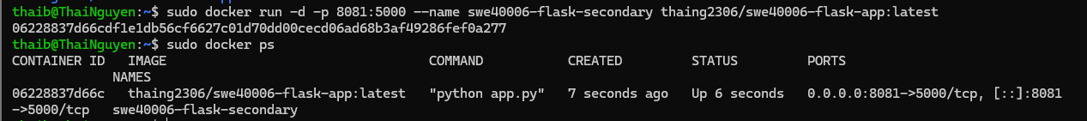
Figure 22: Flask Container Running on the Secondary Docker Environment
The pulled Docker image was successfully deployed as a container in the Ubuntu WSL environment. The container is running with host port 8081 mapped to the Flask application port 5000.
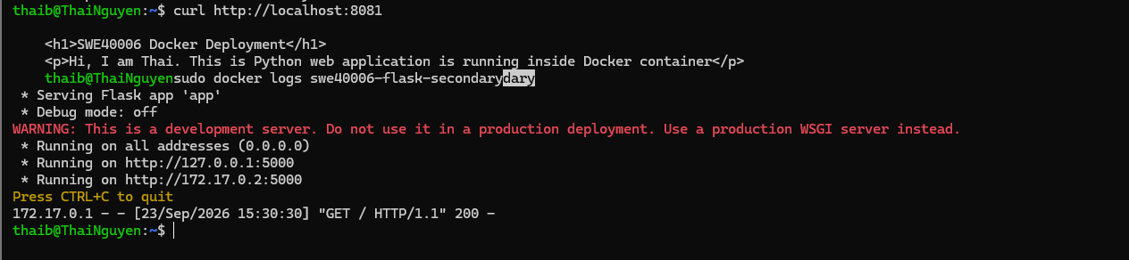
Figure 23: Verifying the Flask Application on the Secondary Docker Environment
The Flask application was successfully accessed through port 8081 in the Ubuntu WSL Docker environment. The container logs show an HTTP 200 response, confirming that the application was running correctly on the secondary Docker environment.
Task 4.3: Distinction Level
- Application Engineering
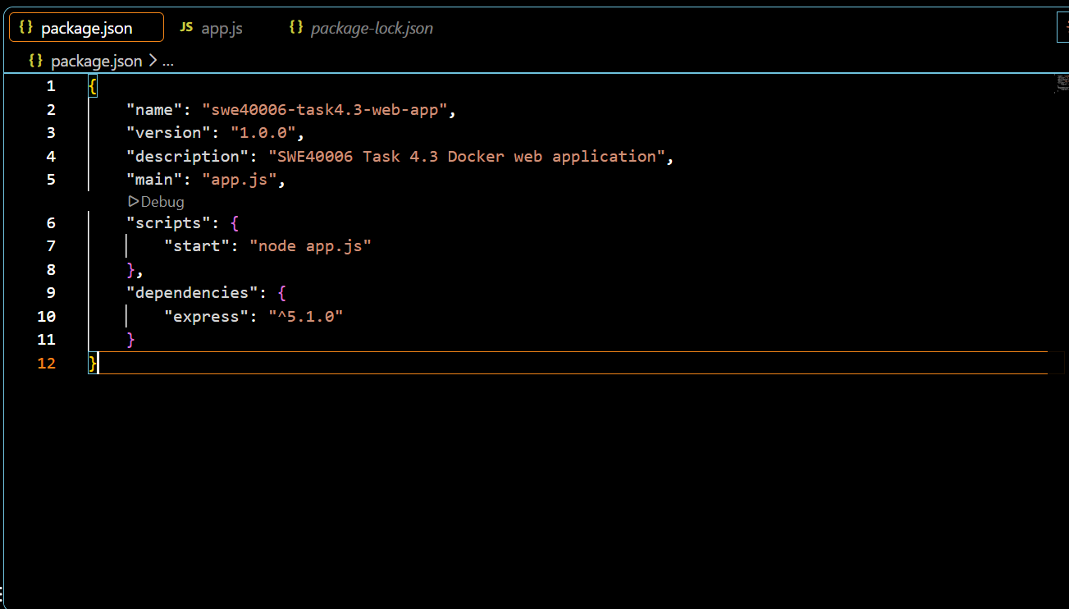
Figure 24: Node.js Application Package Configuration
The package.json file defines the application information, start command, and Express dependency required for the Node.js web application.
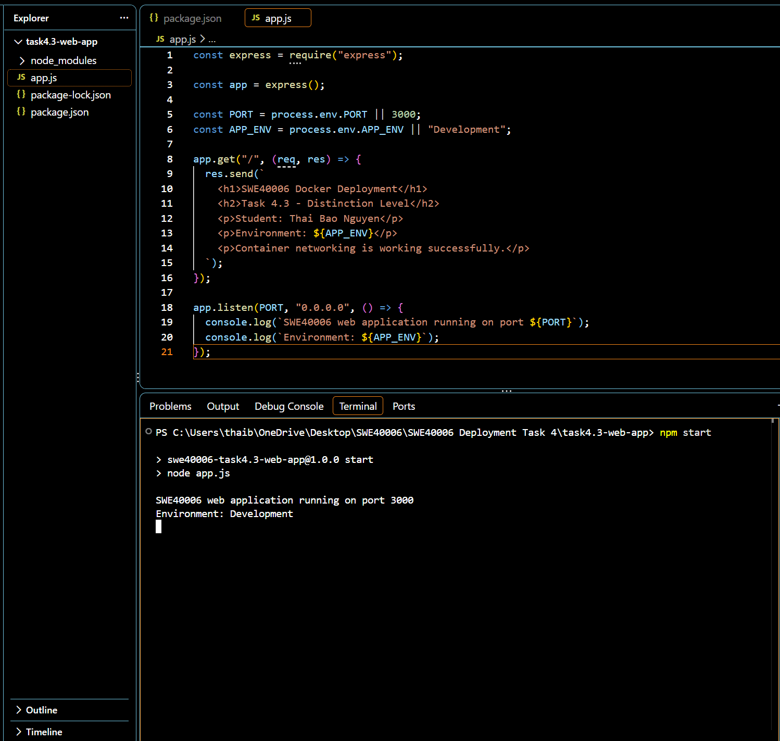
Figure 25: Running the Node.js Web Application Locally
The Node.js application was successfully started using npm start and was running on port 3000 in the Development environment.
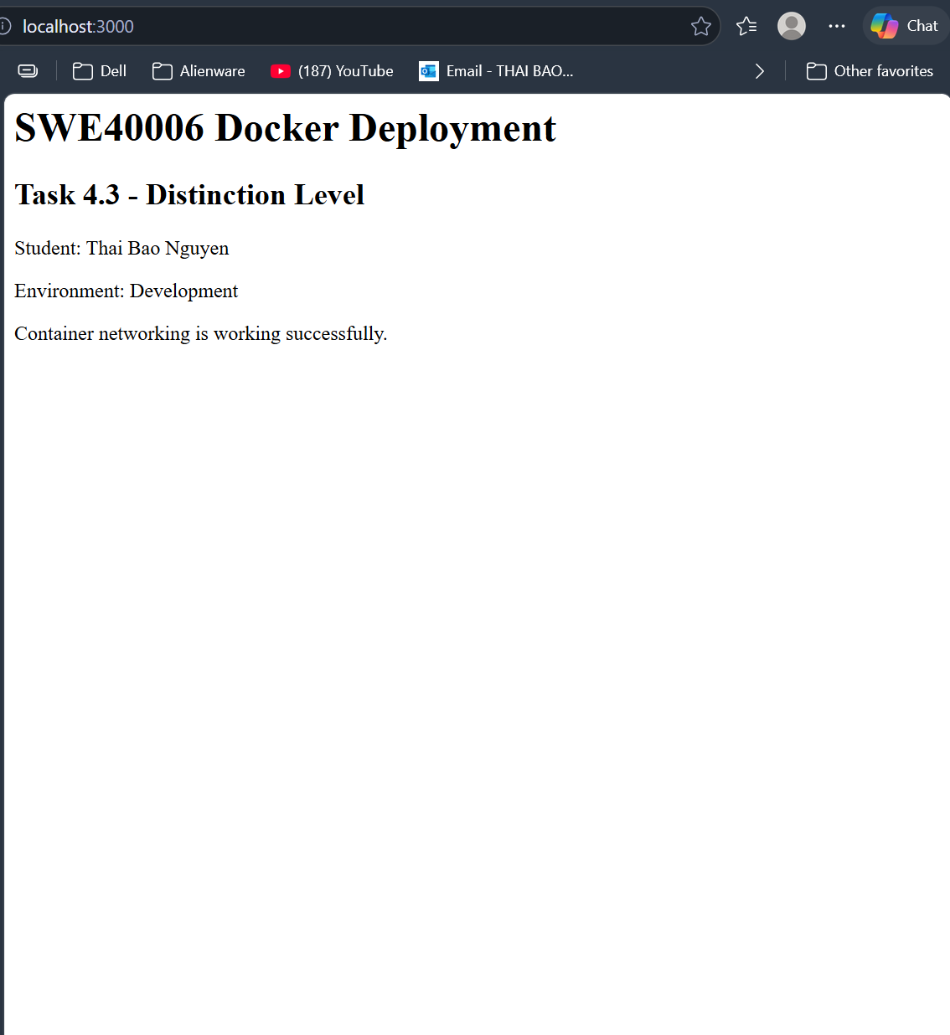
Figure 26: Verifying the Node.js Application on Localhost
The application was successfully accessed through localhost:3000, confirming that the Node.js web application was running correctly in the local environment.
- Container Deployment
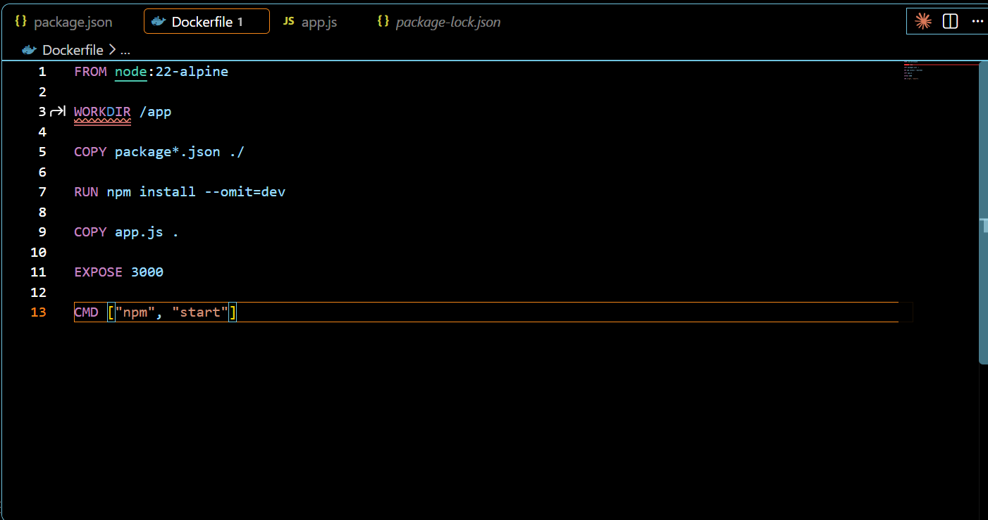
Figure 27: Dockerfile for the Node.js Web Application
A custom Dockerfile was created to configure the Node.js runtime, install the required dependencies, copy the application files, expose port 3000, and start the application using npm.
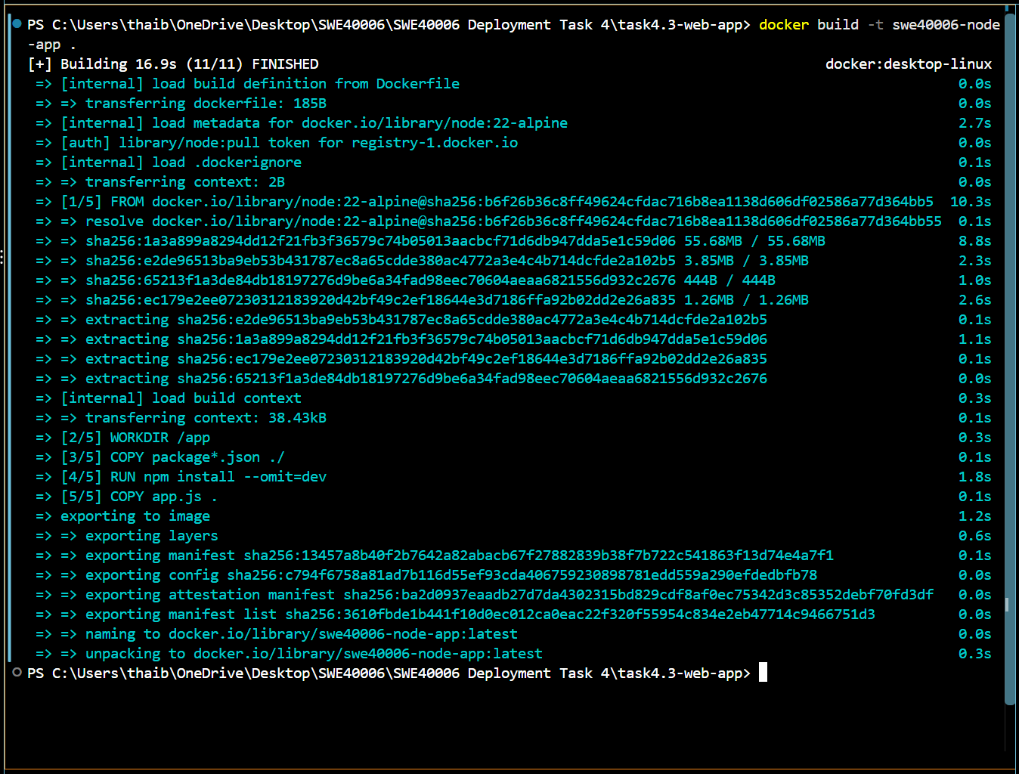
Figure 28: Building the Node.js Application Docker Image
The Node.js application was successfully built into a Docker image named swe40006-node-app using the custom Dockerfile and required dependencies.
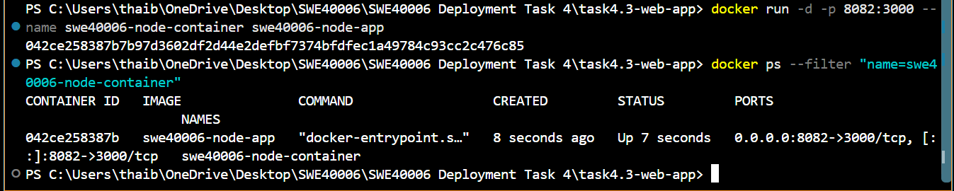
Figure 29: Running the Node.js Application in a Docker Container
The Node.js Docker container was successfully started, with host port 8082 mapped to application port 3000 inside the container.
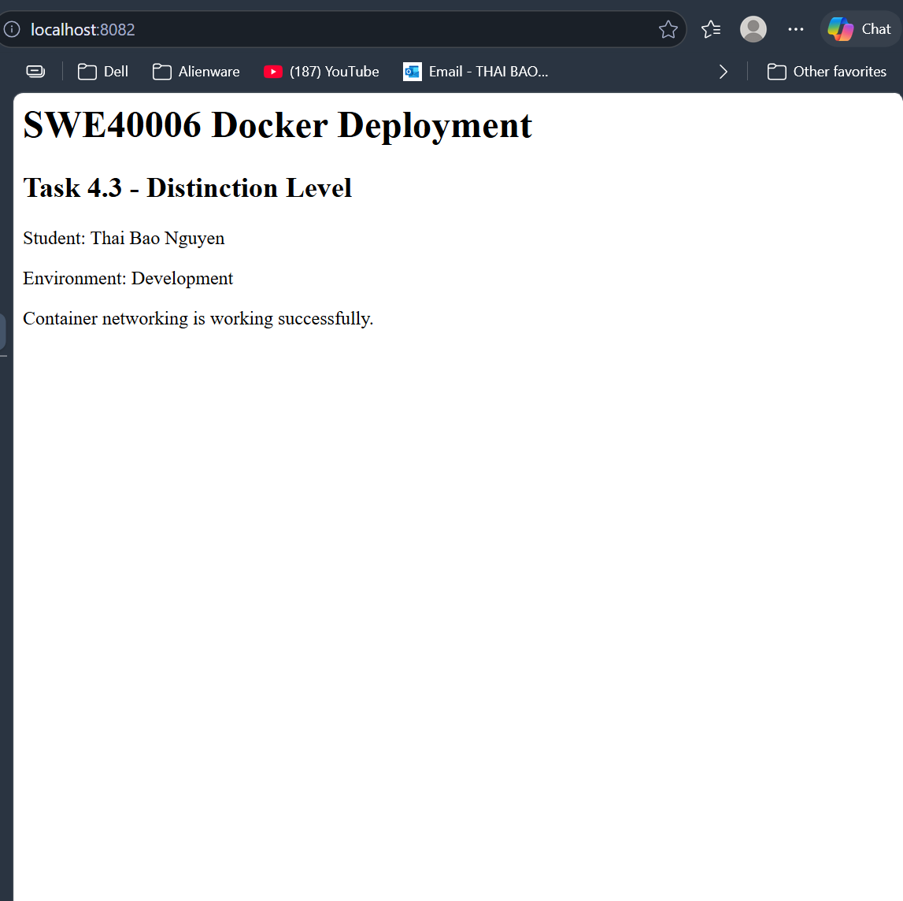
Figure 30: Verifying the Node.js Application Running in Docker
The Node.js application was successfully accessed through localhost:8082, confirming that the application was running correctly inside the Docker container with port 8082 mapped to container port 3000.
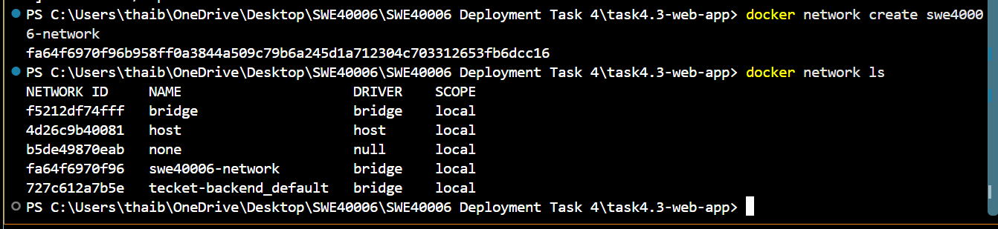
Figure 31: Creating a Custom Docker Bridge Network
A custom Docker bridge network named swe40006-network was created to enable communication between application containers.
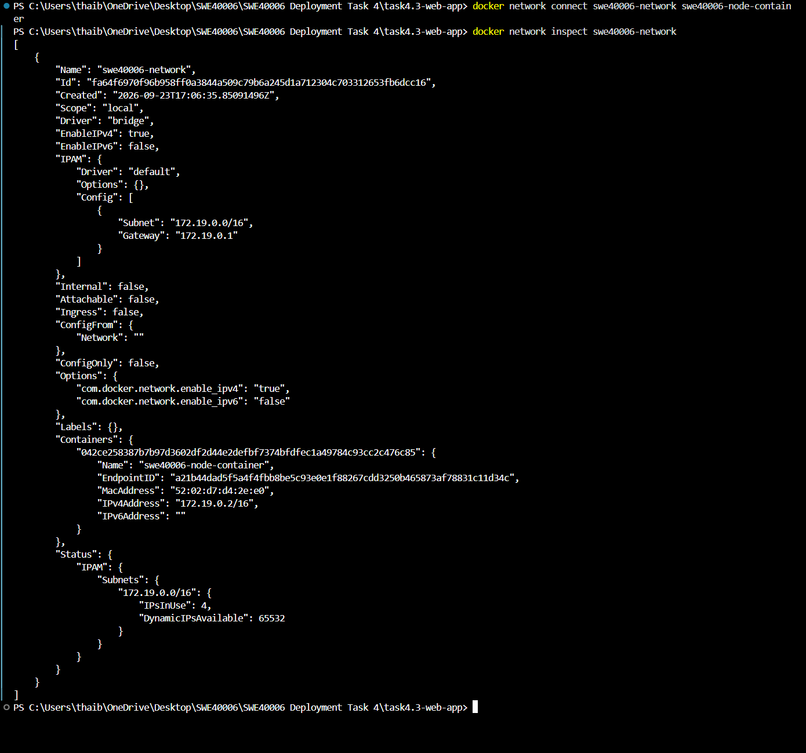
Figure 32: Connecting the Node.js Container to the Custom Docker Network
The Node.js container was successfully connected to swe40006-network. Docker network inspection confirms that the container joined the custom bridge network and was assigned an internal IP address.
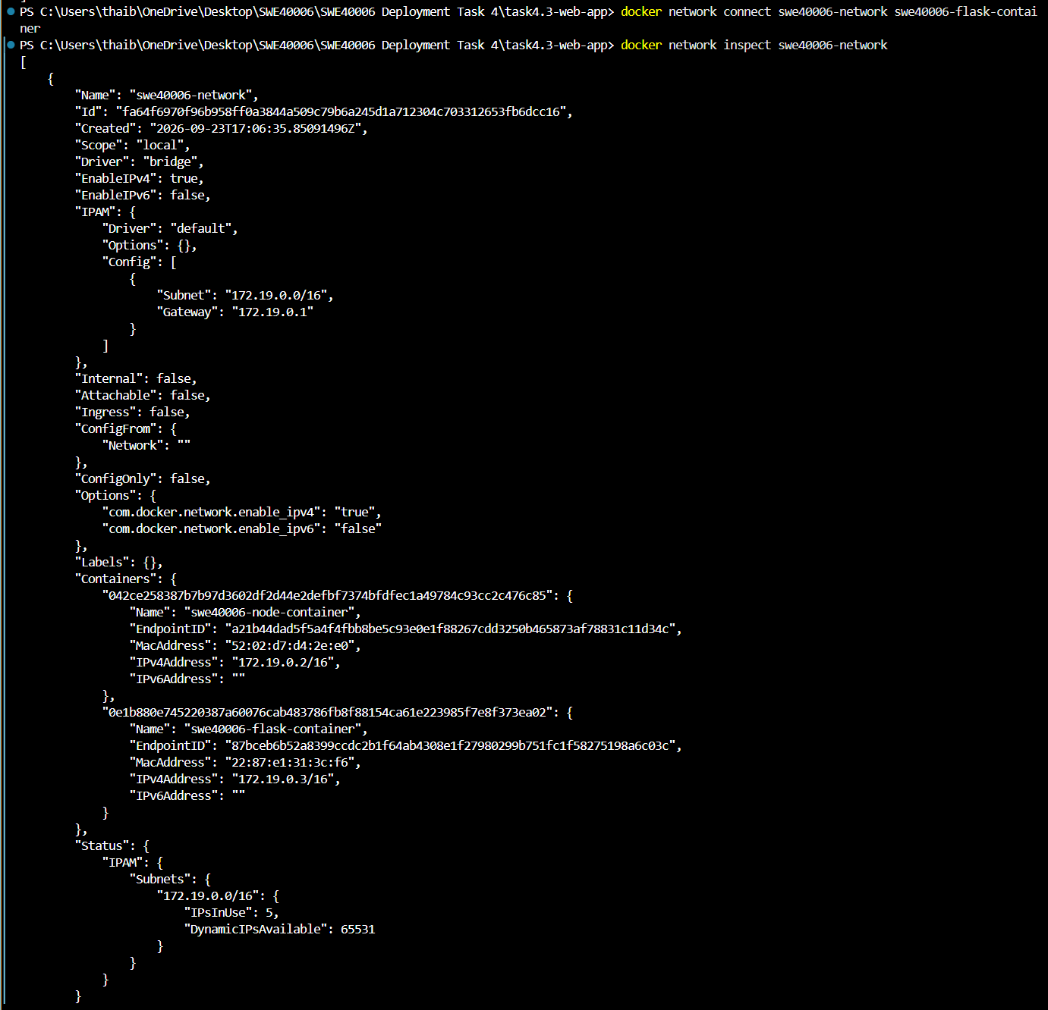
Figure 33: Connecting Multiple Containers to the Custom Docker Network
The Node.js and Flask containers were successfully connected to the same custom bridge network, swe40006-network, allowing communication between the two containers.
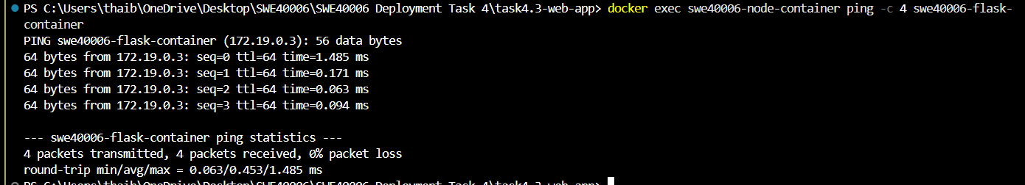
Figure 34: Verifying Communication Between Docker Containers
The Node.js container successfully communicated with the Flask container through the custom Docker network using the container name. All four ping packets were received with 0% packet loss, confirming successful container-to-container communication.
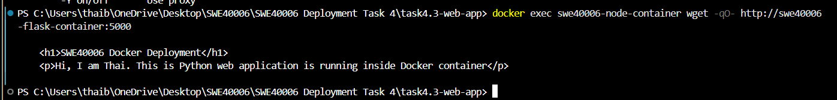
Figure 35: Verifying HTTP Communication Between Docker Containers
The Node.js container successfully accessed the Flask application through the custom Docker network using the Flask container name and port 5000. The returned HTML content confirms successful application-level communication between the two containers.
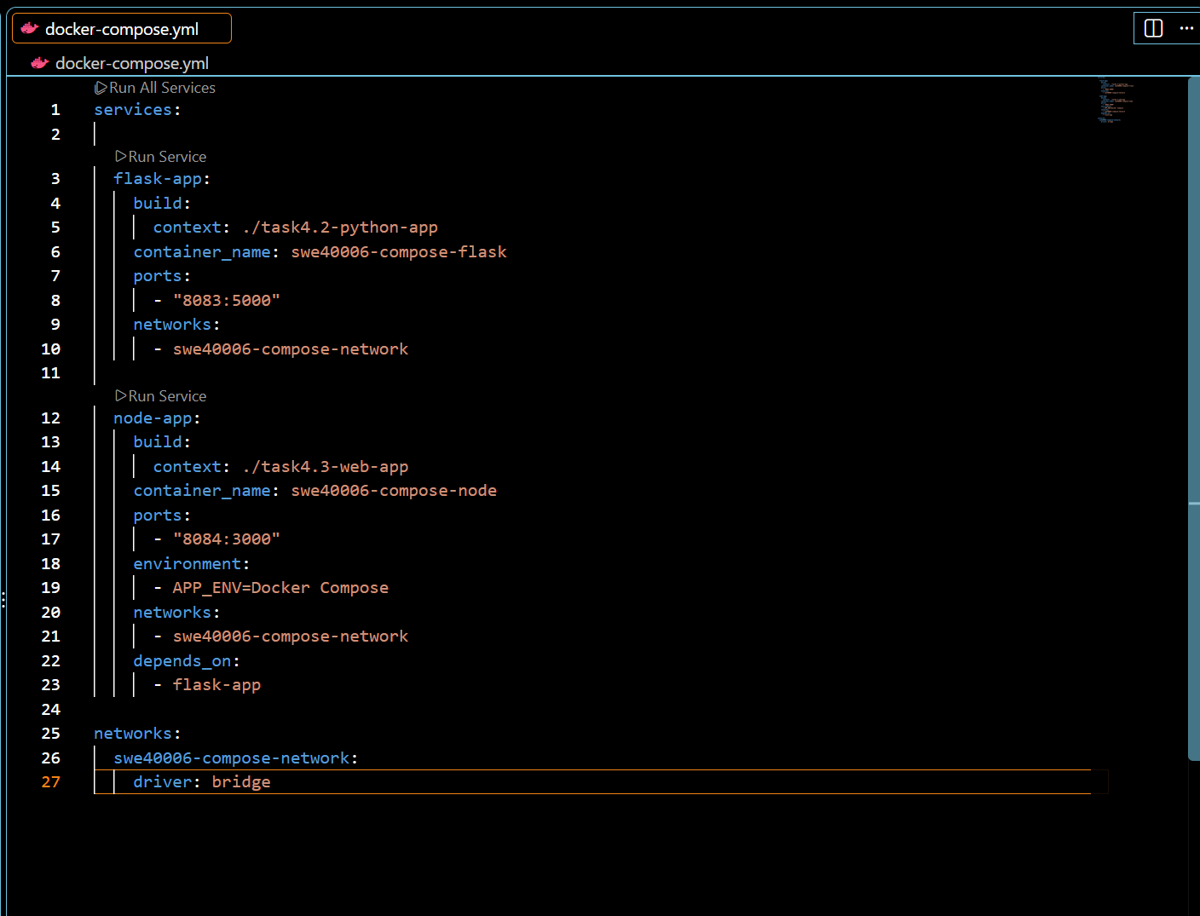
Figure 36: Docker Compose Configuration for Flask and Node.js Services
The Docker Compose file defines the Flask and Node.js services, port mappings, environment configuration, dependency, and a shared Docker bridge network.
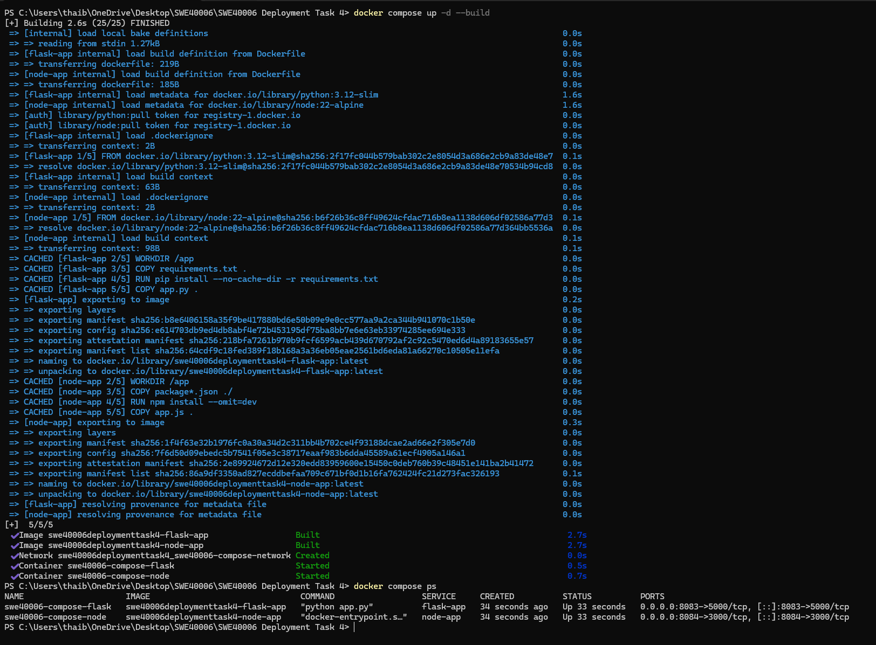
Figure 37: Building and Running Services with Docker Compose
Docker Compose successfully built and started both containers. The output confirms that the Flask service is running on port 8083 and the Node.js service is running on port 8084.
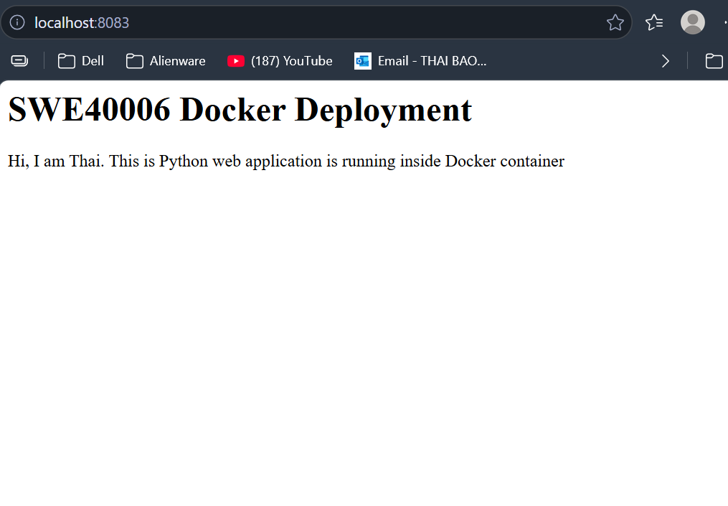
Figure 38: Verifying the Flask Service through Docker Compose
The Flask application was successfully accessed through localhost:8083, confirming that the Flask service is running correctly through Docker Compose.
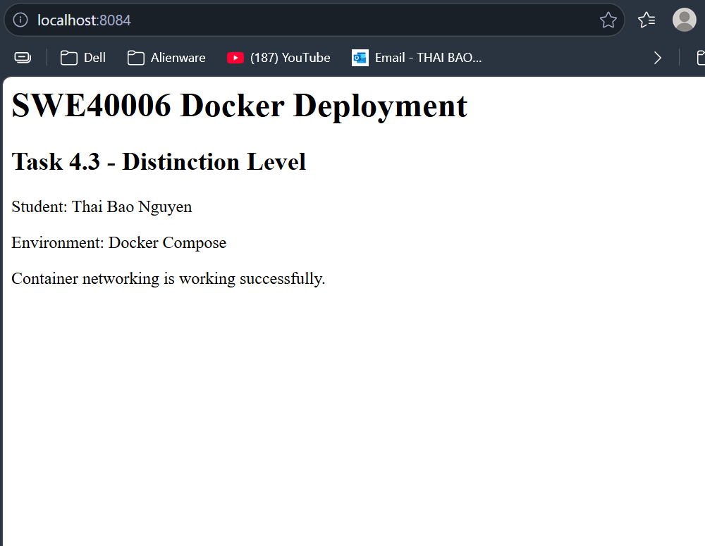
Figure 39: Verifying the Node.js Service through Docker Compose
The Node.js application was successfully accessed through localhost:8084. The displayed Docker Compose environment confirms that the environment variable was passed correctly to the container.
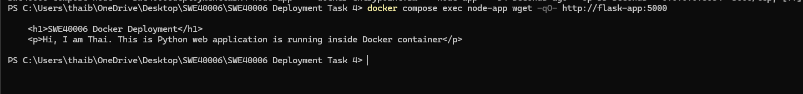
Figure 40: Verifying Inter-Service Communication in Docker Compose
The Node.js service successfully accessed the Flask service using the internal service name flask-app on port 5000. The returned Flask HTML confirms successful communication between the two containers through the Docker Compose network.
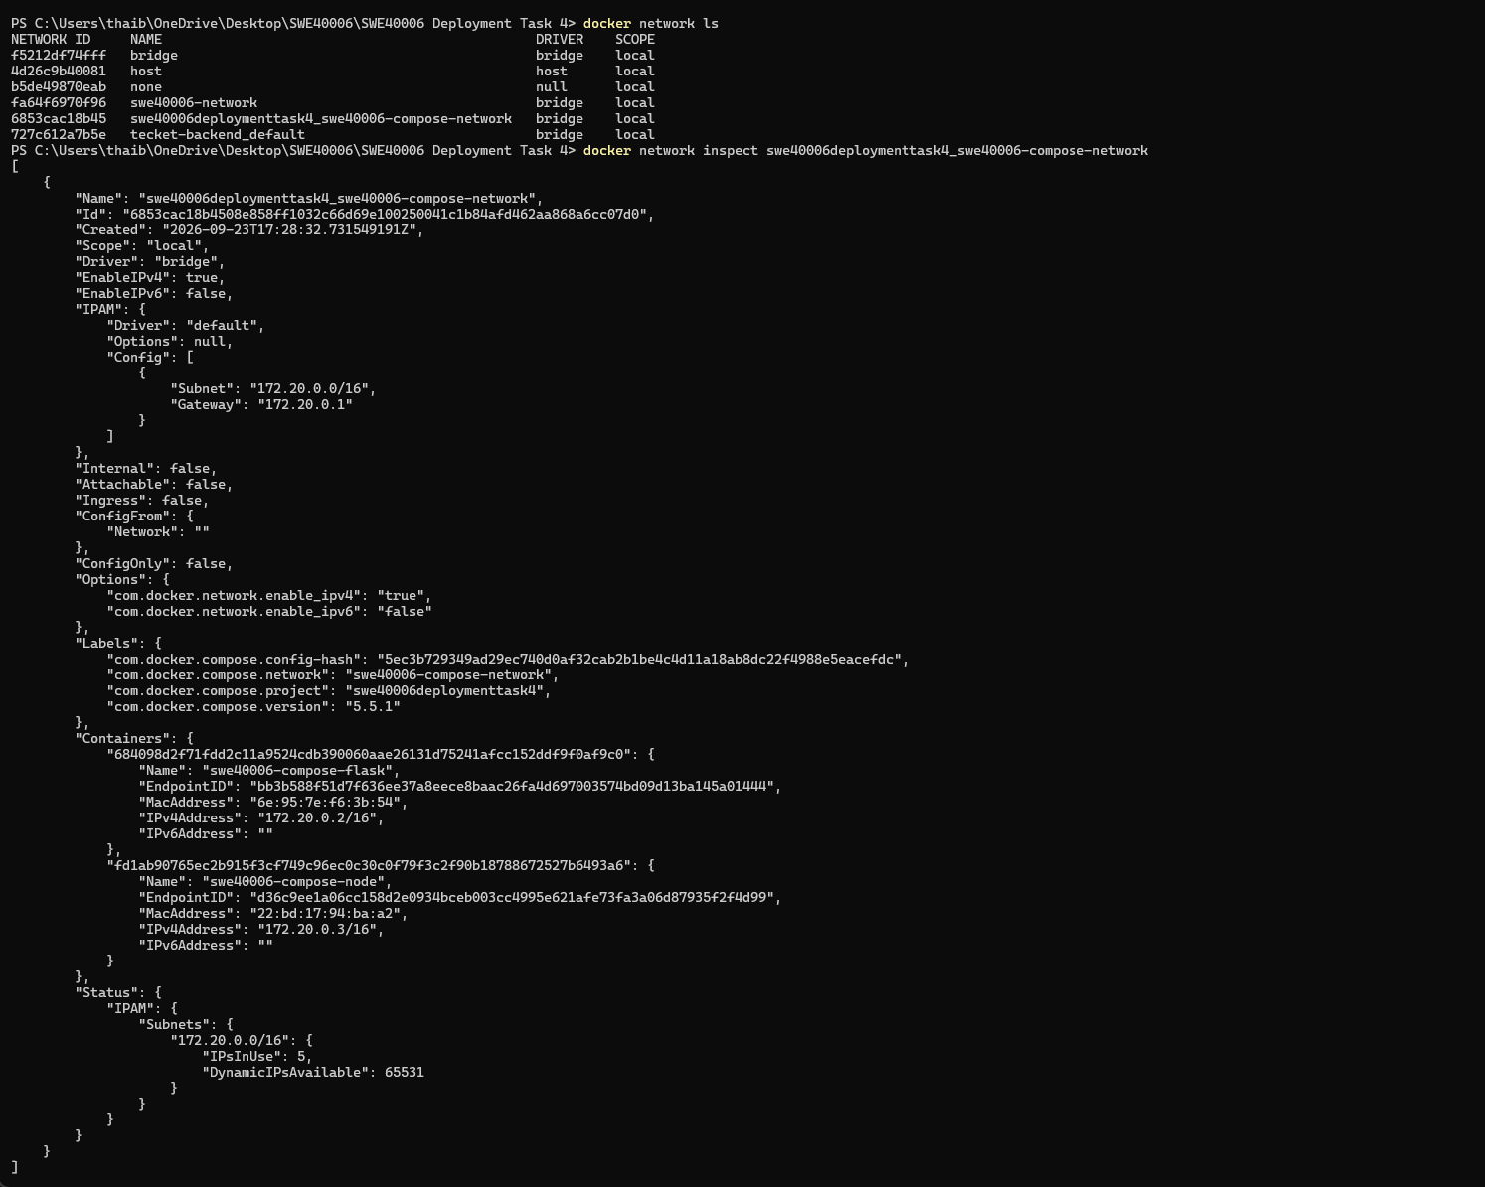
Figure 41: Inspecting the Docker Compose Network
The Docker Compose network was inspected to verify its configuration. Both the Flask and Node.js containers are connected to the same bridge network with separate internal IP addresses, confirming successful network configuration and service connectivity.
Task 4.4: High Distinction Level
- Non-Web Service Development
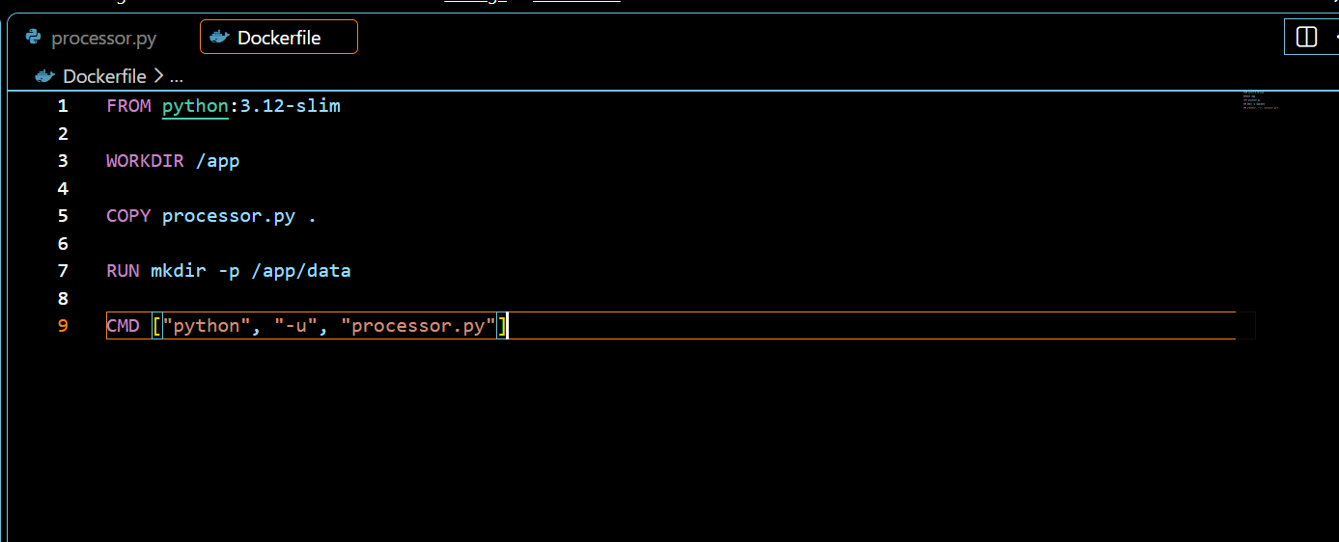
Figure 42: Dockerfile for the Non-Web Application
The Dockerfile was configured with Python 3.12, the application source file, a data directory, and the command required to run the background service.
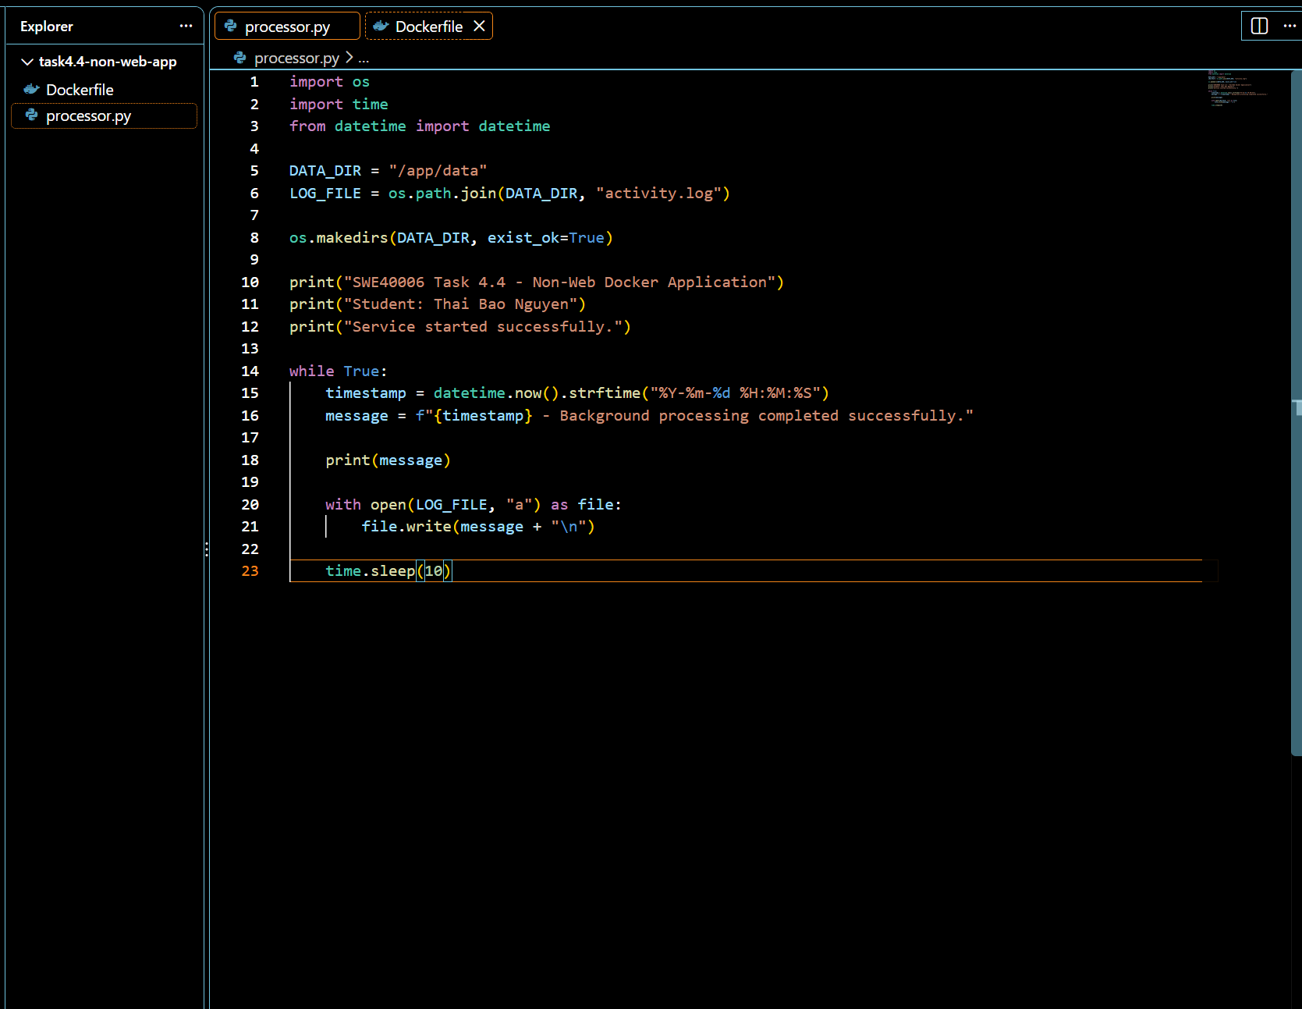
Figure 43: Python Non-Web Application Source Code
The Python application was developed as a background service that periodically processes data and writes activity records to a persistent log file.
- Container Orchestration and Execution
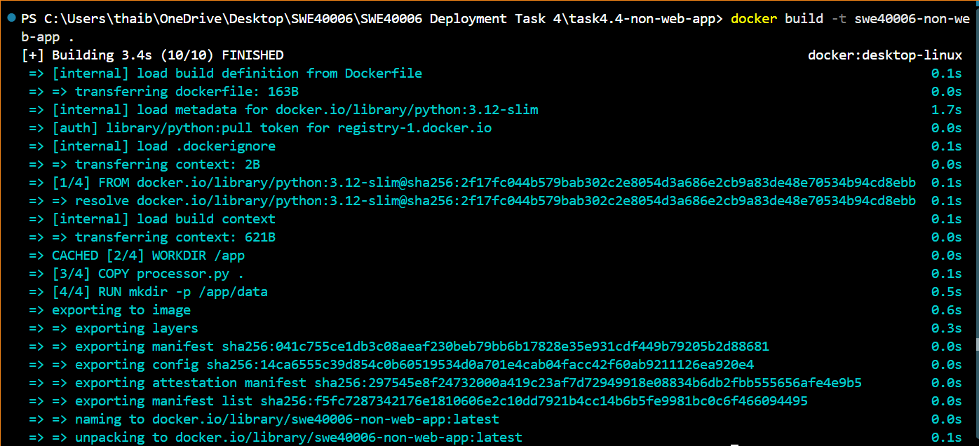
Figure 44: Building the Non-Web Docker Image
The Docker image swe40006-non-web-app was successfully built from the custom Dockerfile.
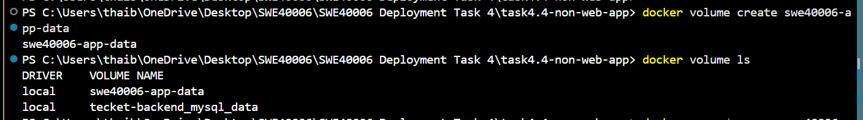
Figure 45: Creating the Persistent Docker Volume
The swe40006-app-data Docker volume was created to provide persistent storage for application data.
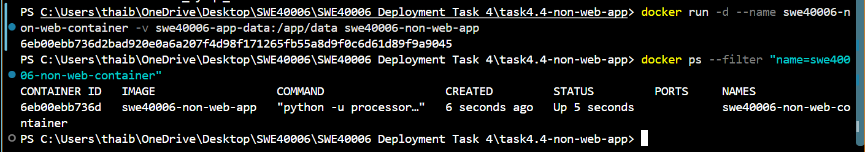
Figure 46: Running the Non-Web Application Container
The swe40006-non-web-container container was successfully started using the custom image with the persistent volume mounted to /app/data.
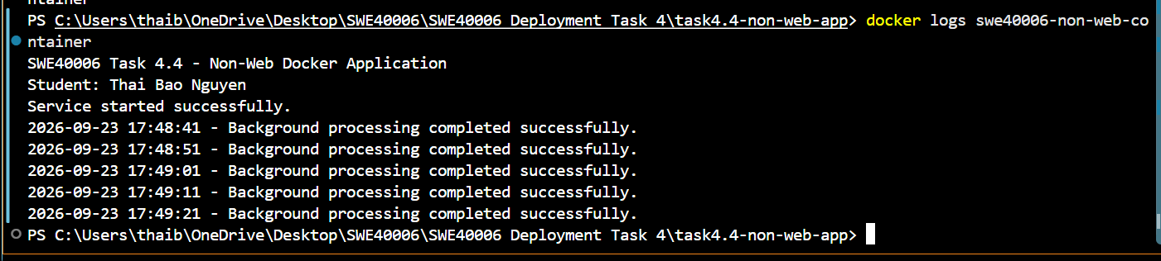
Figure 47: Verifying Non-Web Application Execution Through Logs
The container logs show the background service running continuously and completing processing every 10 seconds, confirming successful container execution.
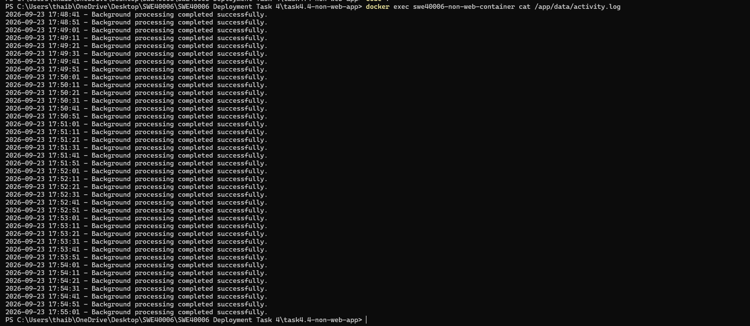
Figure 48: Verifying Application Data Before Container Removal
The activity log confirms that the non-web application continuously writes processing results to the persistent Docker volume.
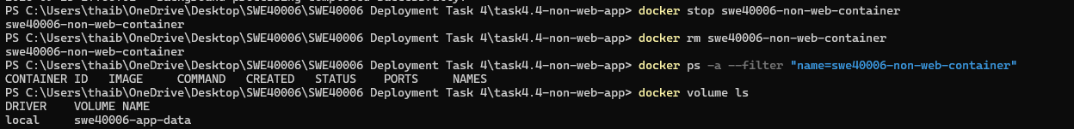
Figure 49: Removing the Container While Retaining the Docker Volume
The original container was stopped and removed, while the swe40006-app-data volume remained available for persistent storage.
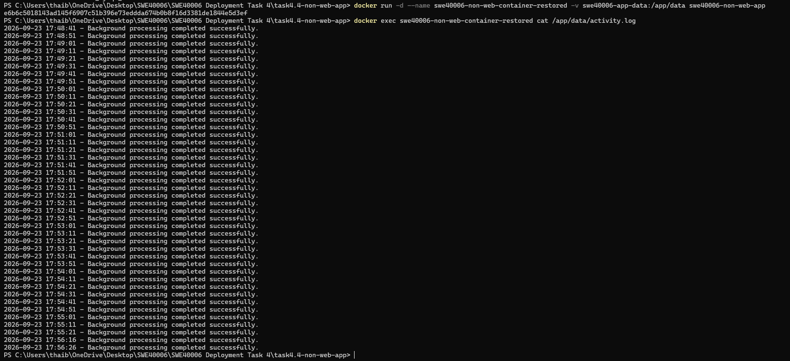
Figure 50: Verifying Persistent Data After Container Recreation
A new container was created using the existing Docker volume. The previous activity records remained available and new records continued to be added, confirming successful persistent storage across the container lifecycle.
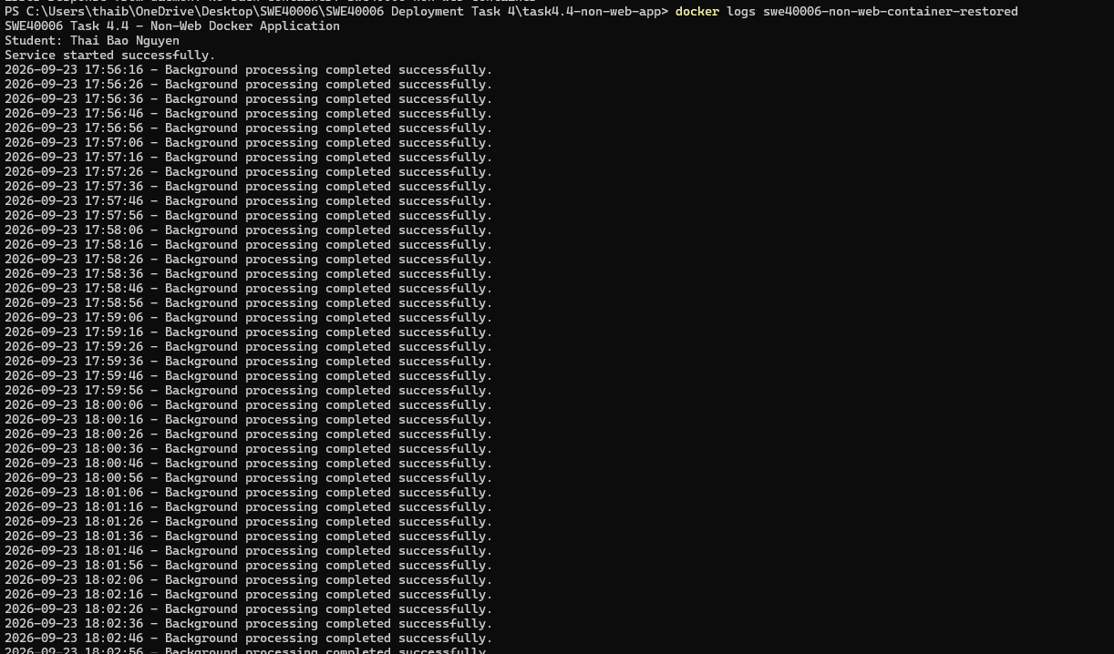
Figure 51: Verifying Non-Web Container Lifecycle Execution
The restored non-web container successfully continued background processing, confirming correct container lifecycle execution after recreation.
Self-Troubleshoot
- Node.js Application Returned “Cannot GET /”
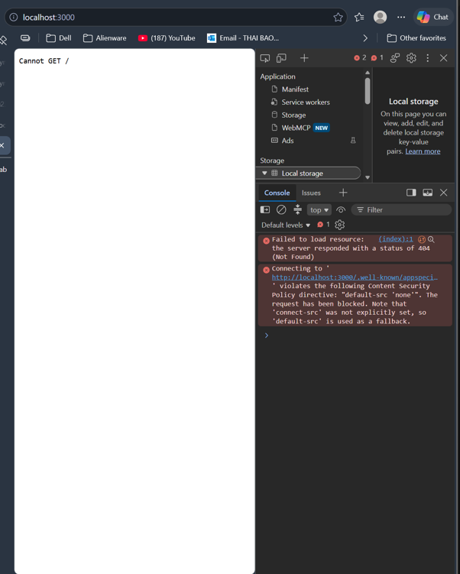
Figure 52: Node.js application returning “Cannot GET /” error
Problem: While testing the Node.js application in Task 4.3, accessing localhost:3000 returned “Cannot GET /” and a 404 (Not Found) response. This indicated that the application was running, but the root / route was not correctly configured.
Solution: I reviewed the Node.js application routing and added or corrected the route handler for /. The Docker image was then rebuilt and the container was restarted with the required port mapping.
Outcome: The Node.js web application successfully displayed its intended page through the browser after the route configuration was corrected.

